IB Biology Lab Format
All labs should follow this format unless otherwise stated by the teacher. They should also be written in third person.
Title/Question – What are you studying? This should include both the independent and dependent variable. Species should have scientific names.
Background – This section should provide information that is relevant and enhances the understanding of the context of the investigation. You should discuss both the independent and dependent variables. It should be clear what the aim, or purpose, of the lab is.
Hypothesis – Based on the information you researched, state your hypothesis.
Variables – This section can be a chart or a list. The dependent and independent variables should be stated with the units they will be measured in. There should also be at least three control variables.
- Independent: The variable that YOU change. Make sure you choose only one of these.
- Dependent: The variable that changes when you change the independent variable (what you measure).
- Controlled: All the aspects of the experiment that must be kept constant to ensure that the tests/experiment is fair.
Materials: List out any materials you used. Make sure to include things such as:
- The sizes of glassware such as beakers, flasks, etc.
- The concentration of chemicals (eg hydrochloric acid, 2.0 M).
- The amounts of chemicals (eg magnesium, 0.50 g).
- The range of a thermometer (eg –20°C to 120°C)
- The amount of each solution (eg 200 mL)
Method – This can be broken down into three parts: procedure, collection of sufficient data, and controlled variables. The procedure may be in list or paragraph form. Do not use first person. Make sure to address any significant safety, ethical or environmental issues that are relevant to the methodology of the investigation. When possible include an image of the experimental set up. Do not include obvious steps such as “Obtain materials and put on safety equipment”. When indicating amounts of materials be sure to maintain precision. For example, if you weighed 20 g of magnesium using a volumetric pipette this should be recorded as 20.00 g and not just 20 g because that is what the scale indicates.
Collection of sufficient data is where you will briefly explain how much data you collected and how you will process that data in order to answer the question.
The controlled variables section is where you will explain how you controlled each controlled variable.
Raw Data – This includes both quantitative and qualitative data. Quantitative data should be organized into a chart. Charts should have titles and uncertainties. All data should have the same number of decimal places.
- The uncertainty for a piece of apparatus is either printed on the apparatus (eg burette, volumetric glassware) or is half the smallest measurable or cited value. For example, if a balance can measure to two decimal places (0.01 g) then the error in a mass reading with this balance is ±0.005 g.
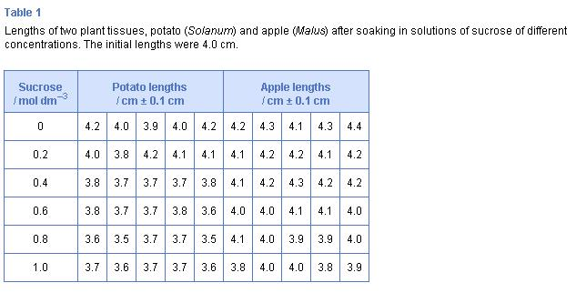
https://mrcovingtonsciencepage.wikispaces.com/IB+Biology+Lab+Report+Guide

Processed Data – Any manipulation of the raw data belongs in this section. This includes averages, standard deviation, t-test, differences, and percent change. Formulas used should be included along with a sample calculation using the raw data.

Processed Data Presentation – This is the graph of your processed data. All graphs should have titles and axis labels. Error bars and keys should be present when applicable. A short description should be underneath the graph.

Conclusion – Discussion of the results and what they imply about the research question. Don’t restate all of your results draw conclusions from them. Be sure to mention any outliers. At least three limitations and what impact they may have had should be described. Human error and time allotment are not limitations. Limitations should be based on the design of the investigation. Are their flaws in the procedure? Is there a variable that should have been controlled? Improvements to correct the limitations should be suggested along with how they would improve the investigation.

