The Blood System Vocabulary
- _______ Arteries
- _______ Veins
- _______ Double circulation
- _______ Tunica externa
- _______ Arterioles
- _______ Venules
- _______ Atrium
- _______ Semilunar valve
- _______ Pulmonary circulation
- _______ Tunica media
- _______ Capillaries
- _______Ventricle
- _______Tunuica intima
- _______ Systolic pressure
- _______ Diastolic pressure
- _______ Systemic circulation
- _______ Single circulation
- _______ Sinoatrial node
- _______ Epinephrine
- ______ Atrioventricular valve

- A thick layer of smooth muscle and elastic fiber found in the walls of the arteries
- Circulation systems that only go through the heart once per circulation
- The minimum pressure in the arteries
- Carry blood back to the heart from the capillaries
- A group of special muscle cells in the right atrium that act as the pacemakers of the heart
- Carry blood away from the heart at high pressure
- The part of the heart responsible for pumping
- The valve between the atrium and the ventricle
- A hormone produced to increase heart rate during physical activity
- Smaller branches of veins
- The outer layer of connective tissue in the arties
- The part of the human circulatory system that takes blood to the lungs and back to the heart
- The peak pressure reached in the artery
- The part of the heart that collects blood from the veins
- Circulation systems that go through the heart twice per circulation
- Smaller branches of arteries
- The layer of endothelium that forms that lining of the artery
- Blood vessels that are very thin and permeable to allow the exchange of oxygen and carbon dioxide between the vessels and the tissues
- The valve between the ventricle and the artery
- The part of the human circulatory system that carries oxygenated blood to the tissues of the body

Heart Diagram

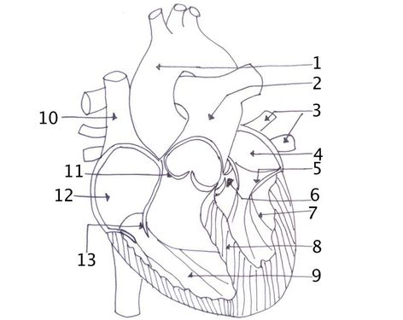
1. Aorta
2. Pulmonary artery
3. Pulmonary veins
4.
5.
6.
7.
8. Septum
9. Vena Cava
10.
11.
12.
13.
 | Artery | Capillary | Vein
Diameter |  |  | Larger than 10um
Thickness of wall and diameter of lumen |  |  | Relatively thin wall with wide lumen
Number of layers in wall |  |  | Three layers (externa, media, interna)
Muscle and elastic fibers in wall |  |  | Small amounts
Valves | None

Around 10um Larger than 10 um None abundant (to manage pressure) None Three layers Present in many veins one layer Thick wall, narrow lumen Extremely thin wall

- Be able to explain how the heart maintains pace and the factors that impact it
- Be able to explain how epinephrine changes heart rate and why
- Be able to explain the pathway of a red blood cell starting in the right atrium
- Be able to explain why veins have valves
- Be able to explain how the structure of the artery helps maintain pressure
- Be able to explain how oxygen and carbon dioxide are exchanged between blood vessels and tissues

