**Digestive system DBQ**

Carotenoids are plant pigments which occur in different forms, such as lutein (from spinach), β-carotene (from carrots), and lycopene (from tomatoes). Researchers investigated the processing of carotenoids from vegetables in the stomach and small intestine. Healthy men were fed three test meals differing only in the vegetable added. The carotenoid content of each test meal was the same. Although the meals were basically liquid, the spinach meal had been made from chopped spinach leaves. The meals were ingested in random order with three-week intervals between them. Prior to the first meal, tubes leading directly into the stomach and small intestine were fitted to each man. Samples of stomach and small intestine contents were collected from these tubes at regular intervals after each meal. Data from this study is shown below.



[Source: Tyssandier *et al*, *American Journal of Physiology*, **284**, (2003), pages 913–922. Copyright 2003 by   
Am Physiological Society. Reproduced with permission of Am Physiological Soc via Copyright Clearance Center]

(a) (i) Calculate the rate of decrease of lycopene concentration in the period 60 minutes to 120 minutes after ingestion in the stomach.(1)

(ii) Predict how many minutes from ingestion it will take lycopene to completely leave the stomach.(1)

(b) Describe the changes in stomach content of lutein, **-carotene and lycopene during the 180 minutes following ingestion.(2)

(c) Suggest a reason why the concentration of lycopene stays relatively constant in the small intestine.(1)

# Label and color

[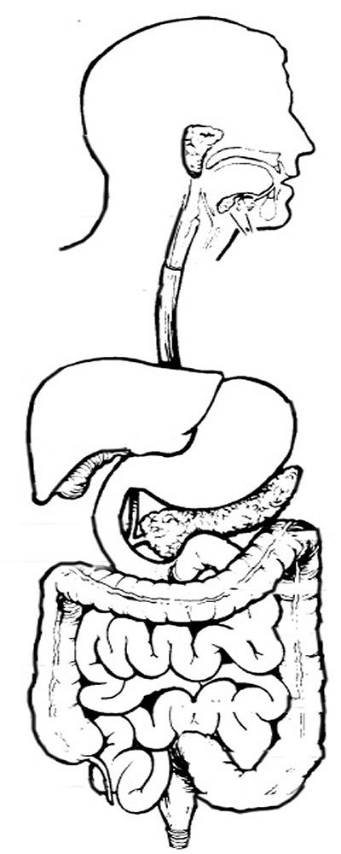](https://www.google.com/url?sa=i&rct=j&q=&esrc=s&source=images&cd=&cad=rja&uact=8&ved=0ahUKEwivzY_X6f3PAhXH7SYKHXKpCeQQjRwIBw&url=https://www.biologycorner.com/anatomy/digestive/digestive_coloring.html&psig=AFQjCNFn0MVWlJB4e2TEC4lAxuITQfPBcQ&ust=1477755279437699)

* Mouth
* Esophagus
* Small intestine
* Stomach
* Pancreas
* Liver
* Gall Bladder
* Large intestine

Use fatty acids and glucose as example to explain how different nutrients are absorbed.

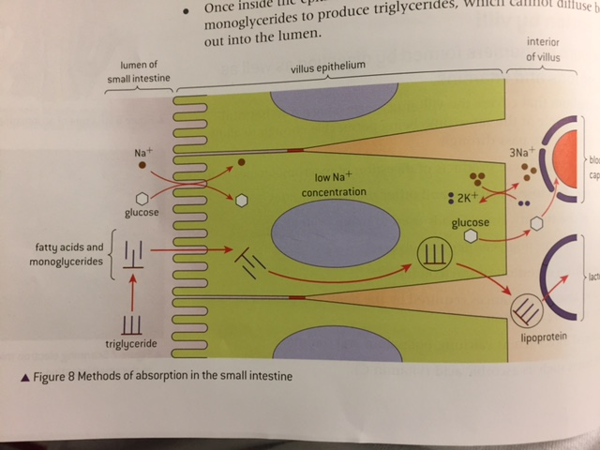

|  |  |  |
| --- | --- | --- |
| Enzyme | Molecule digested | Resulting molecule of digestion |
|  |  |  |
|  |  |  |
|  |  |  |
|  |  |  |
|  |  |  |
|  |  |  |
|  |  |  |
|  |  |  |
|  |  |  |
|  |  |  |

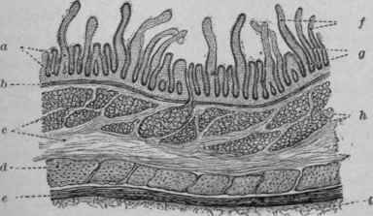

Label the diagram above with serosa, muscle layers, sub-mucosa and muscoa

Use fatty acids and glucose as example to explain how different nutrients are absorbed.

Explain the digestion of starch

Explain the process of peristalsis