IB Biology External Assessment 2016
Your exam has three parts, or papers. They are all weighted differently and have different style questions. Diploma candidates must get at least a three to be eligible for the diploma since this is an HL course.
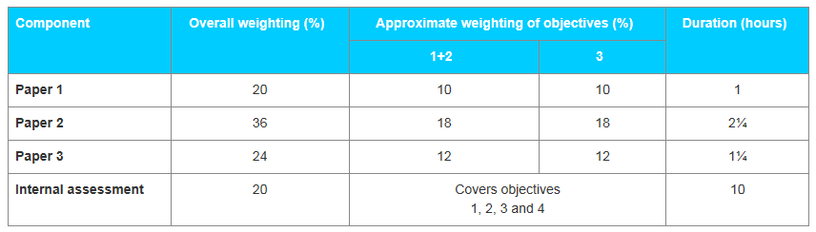
This is your exam. It takes place over two days

Paper 1 | Paper 2 | Paper 3
5/4/16 – morning | 5/4/16 – morning | 5/5/16 - morning
1 hour | 2 ¼ hours | 1 ¼ hours
- 40 multiple-choice questions on core and AHL material, about 15 of which are common with SL.  - The questions on paper 1 test assessment objectives 1, 2 and 3.  - The use of calculators is not permitted.  - No marks are deducted for incorrect answers. (Score is total answered correctly) | - Data-based question.  - Short-answer and extended-response questions on core and AHL material.  - Two out of three extended response questions to be attempted by candidates.  - The questions on paper 2 test assessment objectives 1, 2 and 3.  - The use of calculators is permitted. (See calculator section on the OCC.) | - Section A: candidates answer all questions, two to three short-answer questions based on experimental skills and techniques, analysis and evaluation, using unseen data linked to the core material.  - Section B: short-answer and extended-response questions from one option.  - The questions on paper 3 test assessment objectives 1, 2 and 3.  The use of calculators is permitted. (See calculator section on the OCC.)

