Use the following information to organize and process your data for lab 1
- Set up data table like this in excel and insert data
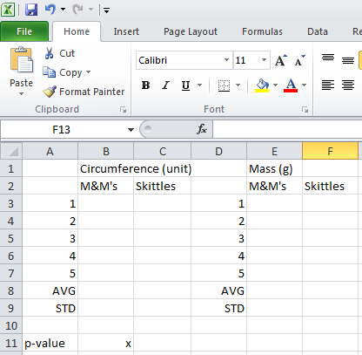
- Merge the highlighted cells by selecting them and clicking “merge and center” (select circumference and click merge and center then select mass and click merge and center)

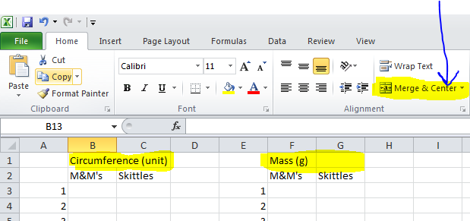

- Add borders by selecting the highlighted cells and clicking format. At the bottom of the menu there is an option for “format cells”. Choose that option.
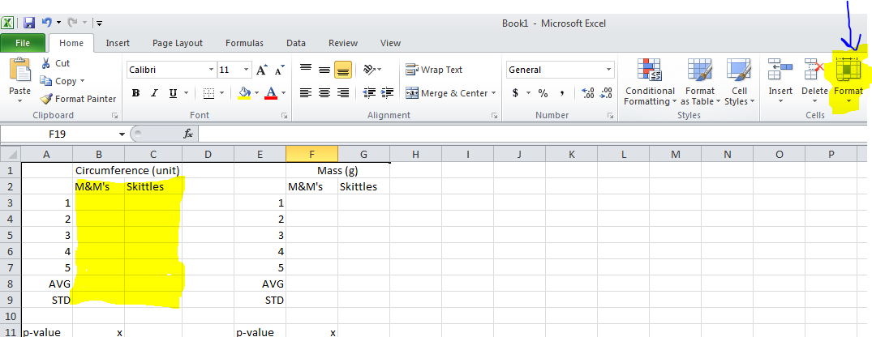

- Click the “Border” tab and chose “outline” and “inside”. Click OK.
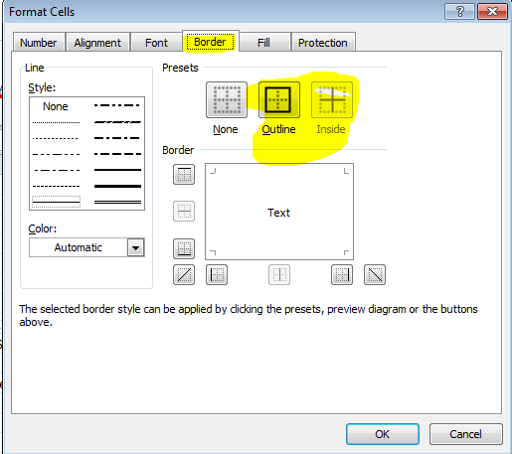

- Repeat 3 and 4 with the highlighted data below
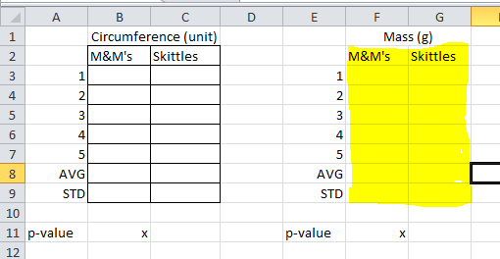

- To find average select the “Formulas” tab and click insert function. Find average from the menu and select your data like the image below
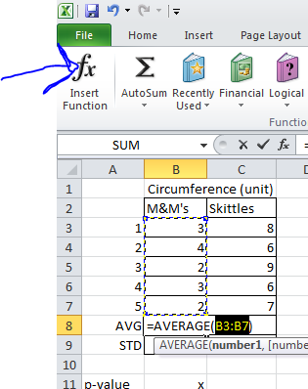
- For standard deviation repeat step six but use standard deviation. Select the same data.

- To do a t-test select that option from the function menu. Set up the t-test so that the information looks like the image below
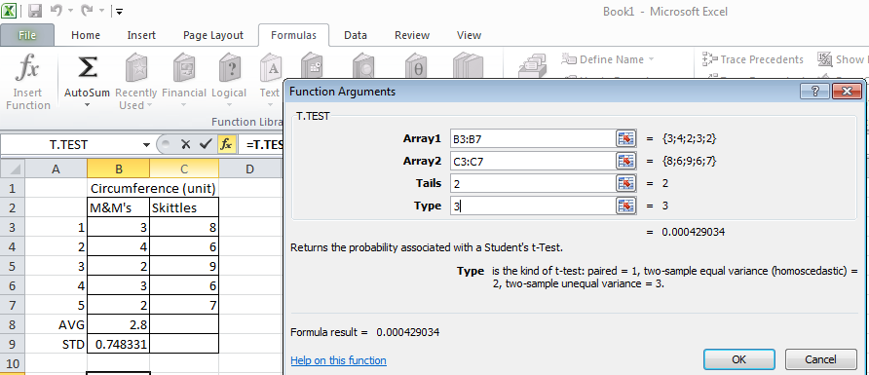

GRAPHING
- Click “insert” and select column graph. Pick the first 2-D option. You should end up with a blank box on your screen.
- Choose “design” an “select data”
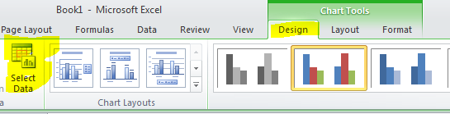
- Choose “add” and enter the series name as M&M’s. Select the M&M average for series value. Click ok.
- Click the 1 and then edit. Enter Type of Candy. Your screen should look like the one below.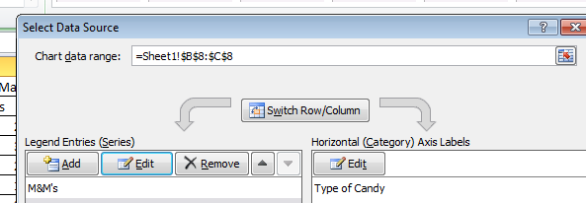
- Click “add” and enter “Skittles” as the series name. Select the Skittles average for the series value. Click ok.

- Click ok to close the menu. Your graph should look like the one below but with your data.
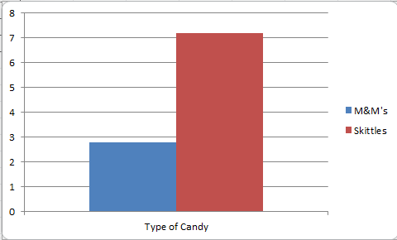
- Use the layout tab to add a title and axis labels. Don’t forget units!
- Click the button for error bars. Select “More error bars options”
- Select the M&M’s series and click ok
- Select the fixed values option and enter your standard deviation for the data and click ok
- Repeat for skittles.
- Email your excel spreadsheet to me or save it to my thumb drive.
- Copy and paste your completed work into your word document that contains the rest of your lab report.

